

Solution Heights Team

Abstract

This document contains an overview to RELISYS WMS which is an integral part of RELISYS ERP

Warehouse Management and Fleet Management

RELISYS ERP

Table of Contents

1. Introduction 3

2. Advantages of RELISYS WMS: 4

3. Functions 5

3.1. Optimization principles 6

3.2. Inbound management 6

3.3. Order processing 6

4. Reports 7

4. Operations 8

5. Operational Cycle 9

6. Technology 10

6.1. Database 10

6.2. Operational System 10

6.3. Scanning equipment 10

6.4. Barcode technology 10

6.5. Integration 10

7. Benefits 11

7.1. Customer Relations Management 11

7.2. Logistics 11

7.3. Maintenance costs 11

7.4. Personnel management 11

7.5. Management accounting and document circulation 11

5. Web App 12

5.1. Location Listing 12

5.2. Location Creation 12

5.3. Warehouse Zone 13

5.3.1. Zone Listing 13

5.4. Zone Creation 13

5.5. Supplier 14

5.5.1. Supplier Creation 14

5.6. Distributor/Agents 14

5.6.1. Distributor Creation 14

5.7. Inbound 15

5.7.1. Advance Shipment Note Advance Shipment Note Listing 15

5.8. ASN Creation 15

5.9. ASN Confirmation: 16

5.9.1. ASN Confirmation Listing: 16

5.10. ASN Confirmation Creation 17

5.11. ASN Confirmation Report 18

5.11.1. Inward Cargo 18

5.12. Batch wise Inward Cargo 18

5.13. Outbound Dispatch 19

5.13.1. Dispatch Order Listing 19

5.14. Dispatch Order Creation 19

5.15. Dispatch Order Creation 19

5.16. Dispatch Order Processing 19

5.17. Ready to Pick 19

5.18. Order Confirmation 19

5.19. Dispatch Note 19

5.20. Inventory operations 19

5.20.1. Stock Utilities 19

5.21. Cycle Count 19

5.22. Inventory Reconciliation 20

5.23. Reports 20

6. Fleet Management 21

6.1. Live Tracking: 21

6.1.1. Vehicle wise search: 22

6.1.2. Area and Category wise search: 22

# Introduction

Relisys Warehouse Management System (WMS) is an application suite designed to optimize warehouse operations. Relisys solutions manage the entire warehouse operation cycle in a real-time mode.

Relisys WMS is a leading-edge system capable of generating recommendations on the optimization of the technological operations in a warehouse as well as managing personnel and material handling equipment in order to achieve the highest performance.

The system eliminates the need for paper documentation. All documentation is generated, transmitted, processed, and optimized in the system. Every operation is confirmed and logged into the system by the operator by either scanning a bar code or entering data via the RF terminal keyboard. Therefore, information on product quantity and allocation in the warehouse is always accurate and up-to-date, so any mistakes or exceptions can be noted and immediately corrected.

The objective of Relisys WMS is the automation of the entire warehouse management cycle - from the point that goods are received at the warehouse up to the delivery of customer orders.

The scope of implementations can vary from basic warehouse control (management system based on paper task lists) to a complex, full-scale warehouse management system in real-time mode using a barcode, RF data transmission, and material handling equipment that positions technologies and other automation means depending on the customers' needs.

The WMS optimizes the put-away and storage of inventory by dividing the warehouse into designated areas and utilizing space in the most efficient way.

The ability to conduct cycle counting during the regular workday reduces or eliminates the need to shut down operations to conduct a physical inventory count. Relisys WMS allows customers to increase quantitative and stowage data accuracy to 99.9% while reducing the duration of receiving and shipping operations by 2-3 times.

Adaptability is one of the most significant features of Relisys WMS. The system can be configured in order to meet the specific operational and business requirements of the customer.

# Advantages of RELISYS WMS:

* Years of experience in warehouse management technologies
* Leading-edge worldwide business algorithms implementation
* Individual approach
* Use the most known development tools and operational systems
* Best worldwide business algorithms implementation
* High performance and elevated system operability
* Advanced functionality
* Integration with various processes and systems through using a developed integration methodology
* Proven implementation technology and training methodology
* Unified open standards
* Unified architecture standard
* Client-server architecture
* Cross-platforming
* Modules structure
* Scalability

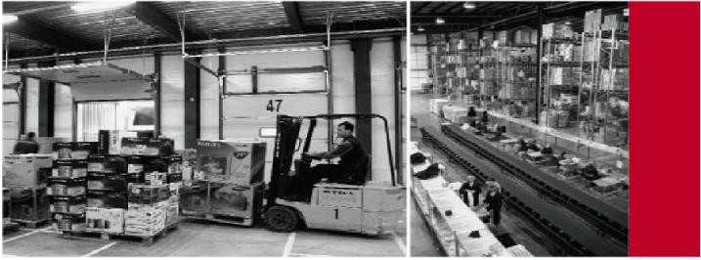

# Functions

RELISYS WMS includes basic as well as additional functionality, depending on the business technologies used in the warehouse and the type of material handling equipment utilized.

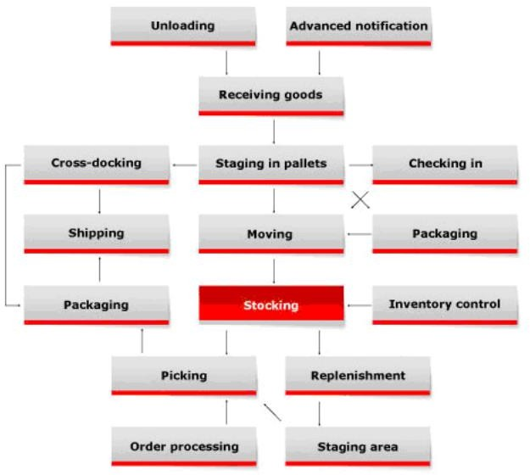

# Optimization principles

* Automatic identification of loads/identity control
* Warehouse zoning
* Control operations in real-time mode
* Authority levels and privileges control
* Keep a record of any event and action
* System configuration
* Report generation
* Support of RF and bar code equipment
* Integration with ERP system
* Statistics exchange
* Auto email alert

# Inbound management

* Advanced notification
* Receive the nonstandard, unpacked product and returns
* Cross-docking Operations on products in stock
* Operations on products in stock
* Put-away and inventory storage rules
* Product age and expiration date control
* QC & quarantine
* Inventory management by FIFO, FEFO, LIFO, LEFO
* Inventory by various units of measure
* Stock inventory
* Physical counting
* Cycle counting

# Order processing

* Order planning
* Goods reservation/backup
* Picking
* Staging
* Wave processing
* Order consolidation
* Order cancellation and processing changes
* Order Confirmation

# Reports

* Inward Cargo Report
* Approved GRN Report
* Batch Wise Inward Report
* Inward Pallet Summary Report
* Inward Aging Report
* In and Out Pallet Summary Report
* In and Out Unit Summary Report
* Date Wise Stock Receipt Summary Report
* Dispatch Note Report
* Dispatch Pallet Detail
* Dispatch Pallet Movement
* Dispatch Pallet Summary Report
* Distributor Wise Dispatch Summary
* SO Wise Delivery Detail Report
* SO Wise Pending Delivery Detail Report
* Order Shipping Summary Report
* Partial Dispatch Note Report
* Storage Summary
* Stock Position Report
* Location Wise Stock Report
* Item Finder Report
* Detail Stock Report
* Expired Stock Report
* In hand Inventory Report
* Cycle Count Report
* Aging Report
* Batch Wise In hand Inventory
* Other customization reports

# Operations

The warehouse is divided into specified areas according to technological operations in order to automate inbound, outbound, and in-stock operations. The system enables the client to create a series of work algorithms to assign personnel in the most efficient manner, to accomplish warehousing and inventory movement responsibilities.

Relisys WMS controls task fulfillment through the scanning of a bar code. Storage locations/storage units, loads, and vehicles are all marked with bar codes. The system supports code-128 bar code type, and labels with internal bar codes can be printed out.

By following designated put-away rules, Relisys WMS automatically chooses the appropriate storage place for loads that are received and generates tasks for operators to move the loads.

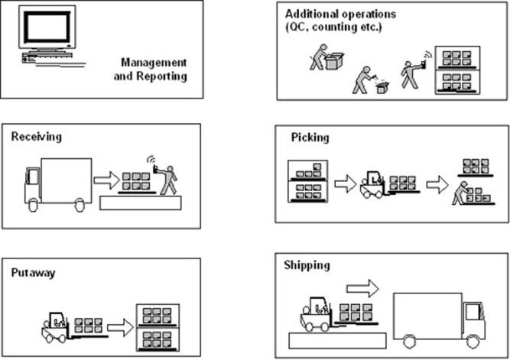

The system controls the movement of every employee and is able to eliminate errors in order picking, inventory put away as well as the periodic movement of goods in the warehouse.

Information on load allocation, availability of products, personnel activity, and completed tasks are continuously updated in the system.

The system generates reports on current warehouse status or fulfilled operations. The reports can be printed out or sent to the client's ERP. The customer can choose the type and number of reports during the requirement specification and development stage.

# Operational Cycle

Relisys WMS is an application suite designed to optimize warehouse operations. Relisys solutions manage the entire warehouse operation cycle in a real-time mode. The System controls warehouse personnel as well as material handling equipment, and operatively generates tasks for users based on a current situation.

Relisys WMS is based on automatic identification technologies (such as barcoding and others), the principle of mapping warehouse locations, and assigning unique storage locations to inventory and remote personnel management. Every warehouse operator is equipped with an RF terminal - a mobile computer that can either be handheld or mounted on a fork truck. Using the Relisys WMS your warehouse will be functioning as an integrated and well-controlled complex, bringing together all the resources and capable of interaction with other elements of the logistics chain. Relisys WMS will be a key component of the complex.

# Technology

# Database

The system is integrated with the below DBMS:

MS SQL 2017

# Operational System

The system is based on the Linux platform, while client applications are browsers base.

# Scanning equipment

We offer t and improve logistics management. he most reliable up-to-date scanning equipment (RF & Mobile devices) that enables you to increase performance

# Barcode technology

A label with a barcode is applied to loads. Depending on the standard, the barcode can encode any information such as product profile, expiry date, and others. It can be used for the unique identification of loads. A barcode is a series of varying width vertical lines (called bars) and spaces. Tracking physical assets, inventory, and personnel with automated systems can save money and improve operations.

# Integration

Integration methodology with ERP systems was developed during numerous project implementations. Relisys WMS successfully integrated with SAP, Oracle, and others

# Benefits

# Customer Relations Management

* Eliminate non-standard order shipment, create reports of extra shipment or order return
* Reduce expired product write off costs
* Increase quality of services.

# Logistics

* Optimize warehouse inventory flow
* Increase quantitative and storage data accuracy to 99.9%
* Complete control over inventory flow
* Warehouse space optimization
* Increase inventory through-put and turns
* Employ best put away strategies.

# Maintenance costs

* Material handling equipment rational utilization
* Equipment deployment optimization

# Personnel management

* Increase employee efficiency
* Eliminate employee errors and increase accountability
* Reduce time required for warehouse processes
* Enhance labor productivity

# Management accounting and document circulation

* Speed up data interchange
* Data access in real-time mode
* Reduce paperwork
* Inventory control without interrupting warehouse operation
* Integration with corporate systems

# Web App

# Location Listing

Users can search locations based on filter criteria. Users can add and edit new locations.

# Location Creation

Users can configure a new location for the warehouse by giving input in fields.

# Warehouse Zone

# Zone Listing

Users can search zone based on filter criteria. Users can add and edit new zones here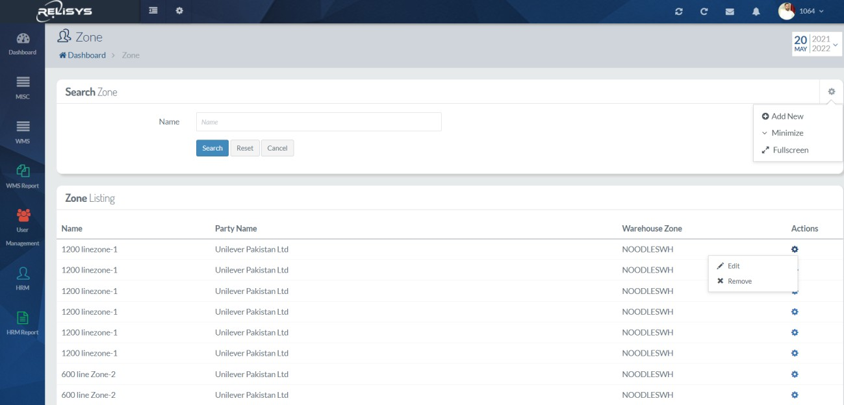

# Zone Creation

Users can configure a new zone for the warehouse by giving input in fields.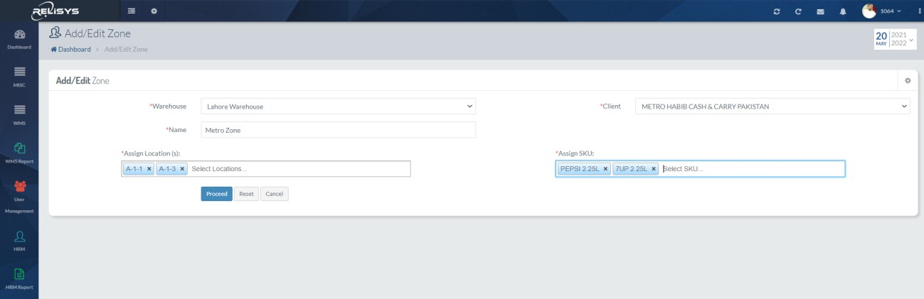

# Supplier

# Supplier Creation

Users can configure a new supplier for inbound by giving input in fields.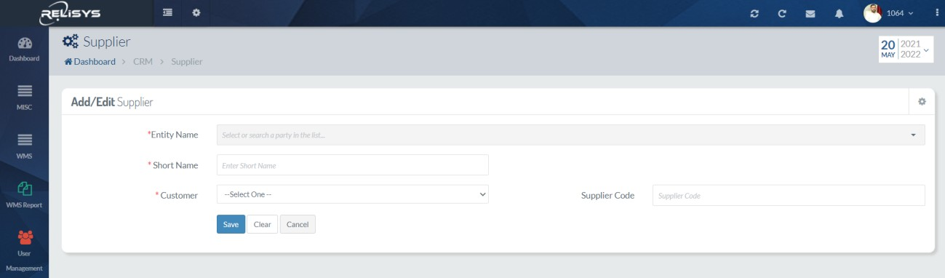

# Distributor/Agents

# Distributor Creation

Users can configure a new distributor for dispatches by giving input in fields.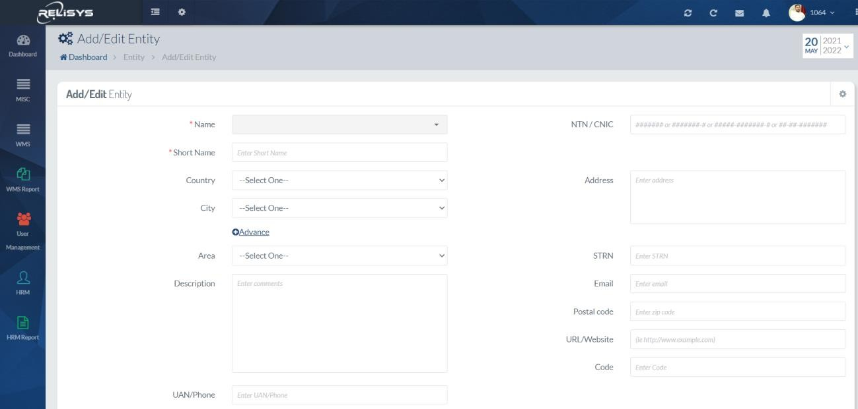

# Inbound

# Advance Shipment Note Advance Shipment Note Listing

User can search ASN base on filter criteria. User can add and edit new ASN here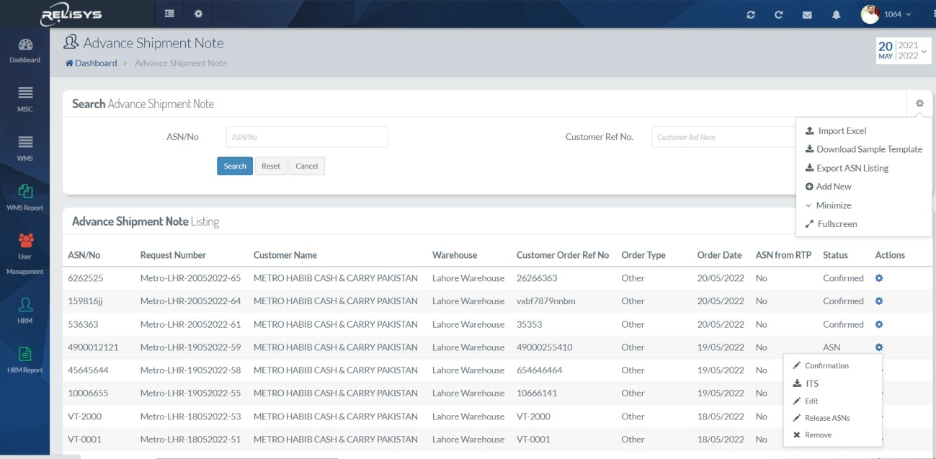

# ASN Creation

Users can create ASN by giving input in fields.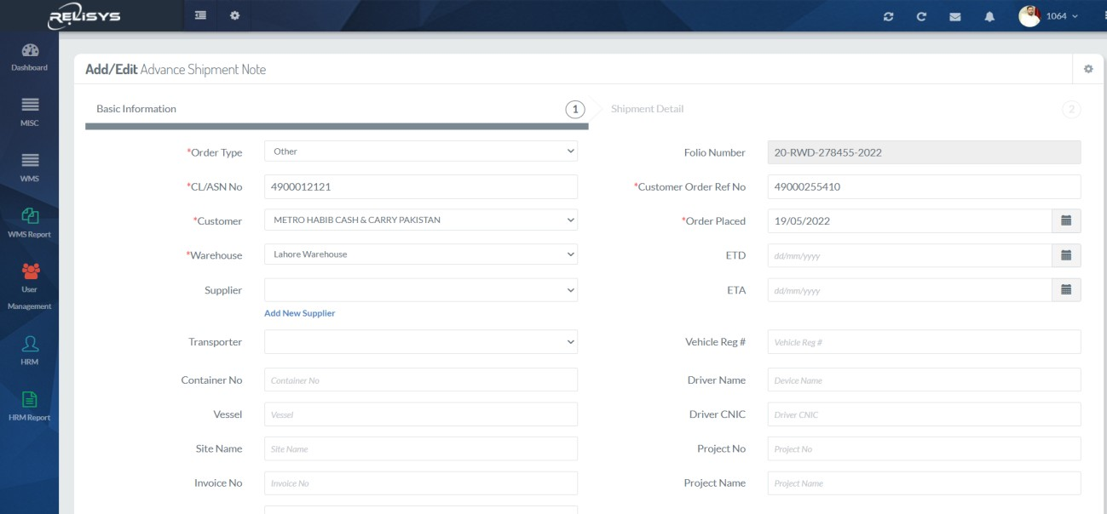

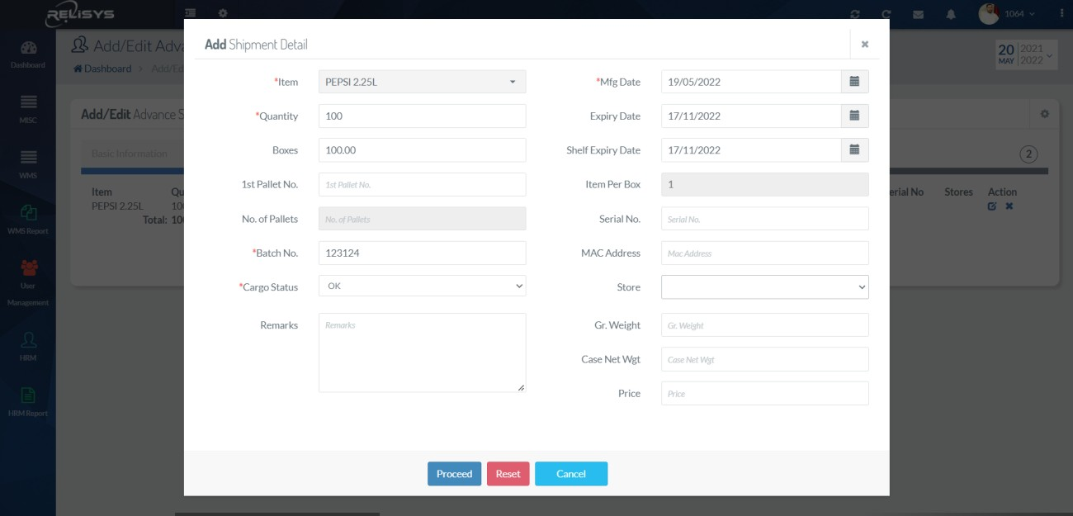

# ASN Confirmation:

# ASN Confirmation Listing:

User can search ASN base on filter criteria. User can confirm ASN here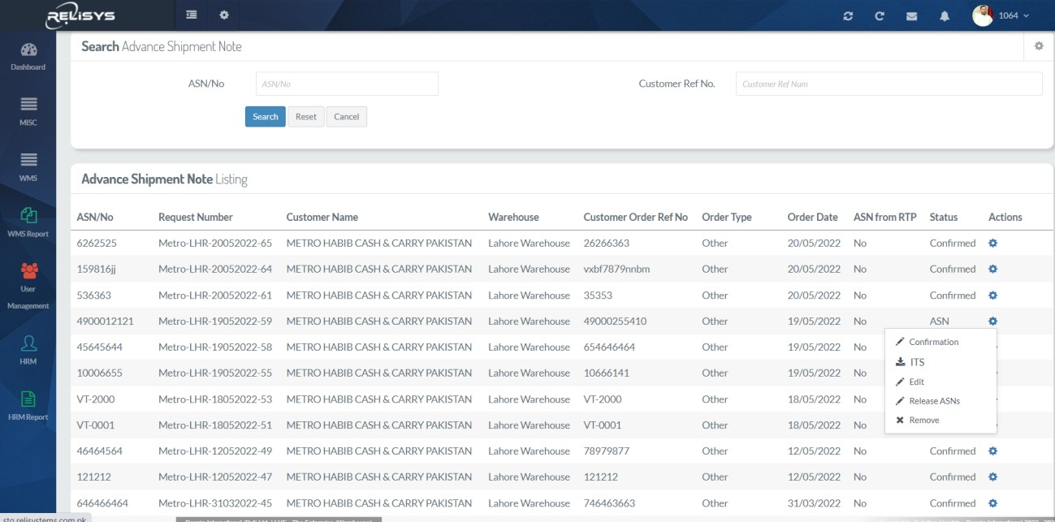

# ASN Confirmation Creation

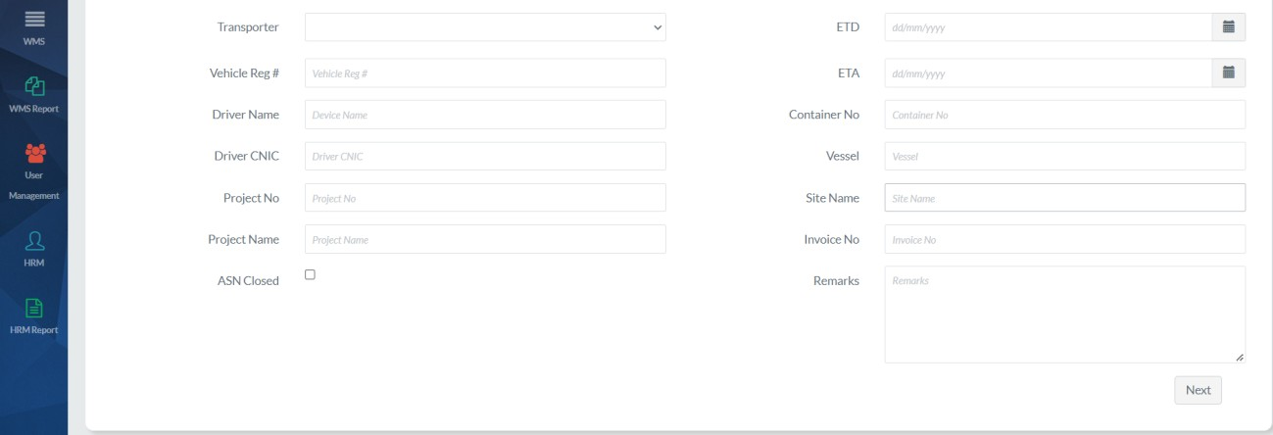Users can confirm ASN by giving input in fields and Location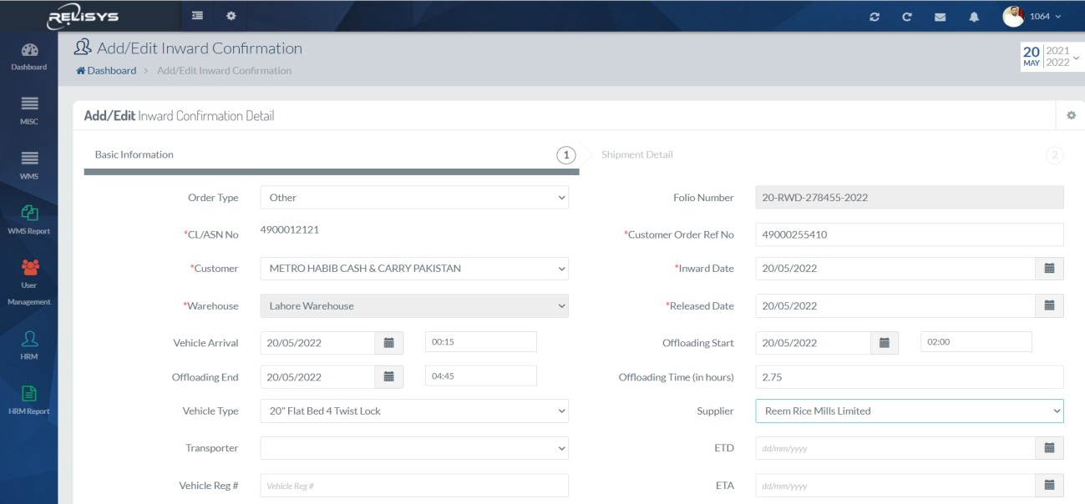

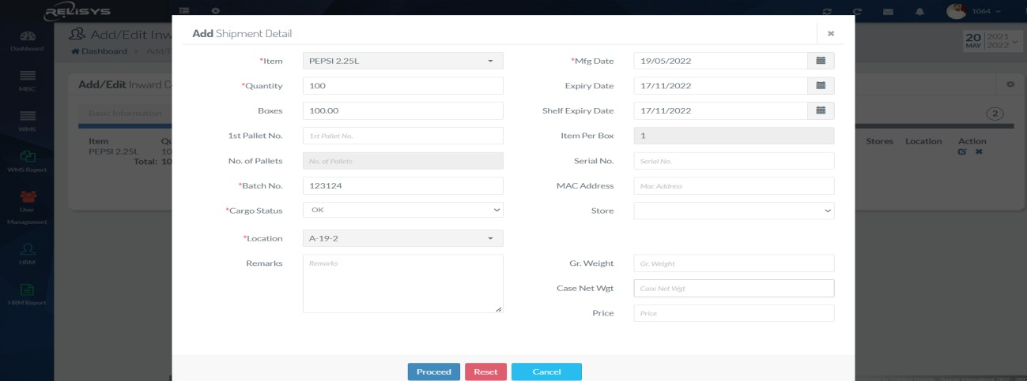

# ASN Confirmation Report

# Inward Cargo

Users can download and print a report of ASN confirmation

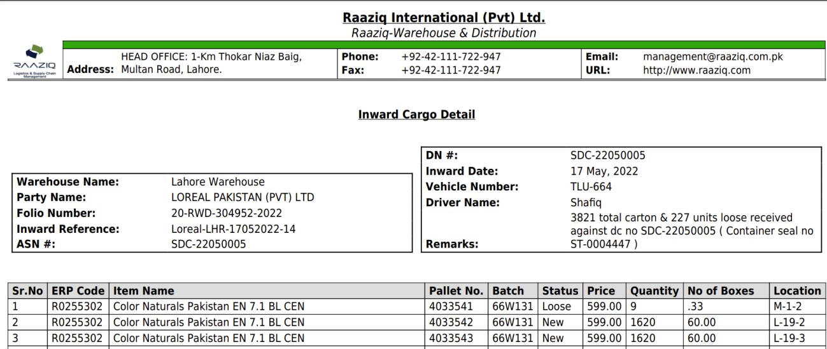

# Batch wise Inward Cargo

Users can download and print a report of batch-wise inward cargo report against confirmation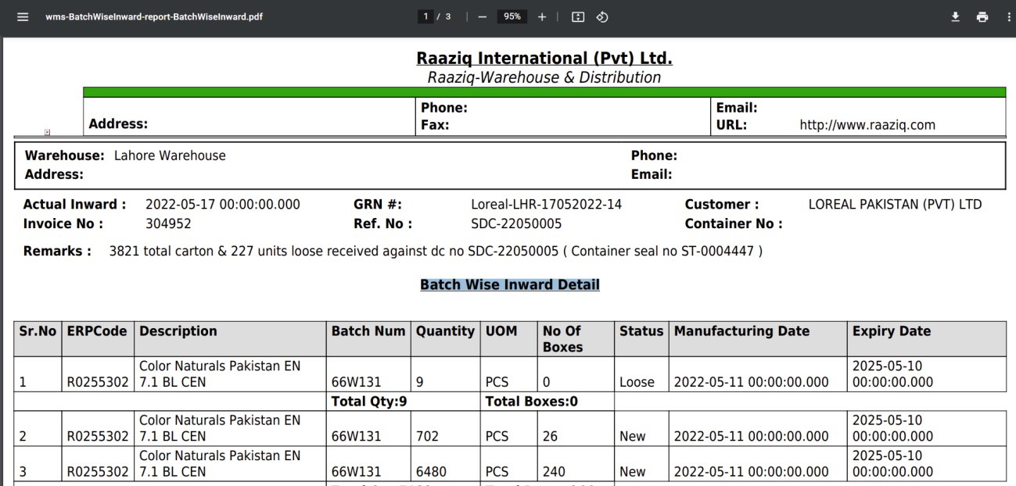

# Outbound Dispatch

# Dispatch Order Listing

Users can search Dispatch Request based on filter criteria. Users can add and edit new orders here

# Dispatch Order Creation

Users can configure a new order for the warehouse by giving input in fields.

# Dispatch Order Creation

Users can configure a new order for the warehouse by giving input in fields.

# Dispatch Order Processing

Users can process the order to generate the pick list for order picking.

# Ready to Pick

Users can mark ready to pick against the order that has been picked

# Order Confirmation

Users can confirm the order that has been shipped from the warehouse by giving input in the fields

# Dispatch Note

Users can create the dispatch note against orders that have been confirmed.

# Inventory operations

# Stock Utilities

Users can perform the Cargo status, Location change, Batch change, and Manufacturing date change operation on the inventory

# Cycle Count

Users can perform cycle count based on tasks generated by the system

# Inventory Reconciliation

Users can perform reconciliation with customer system by uploading in given sample format

# Reports

Multiple reports are available for inbound, outbound, and inventory. The list of reports is below.

# Fleet Management

# Live Tracking:

Features:

* Real-Time Location.
* Tracking Customizable Alerts.
* Route Optimization and Scheduling.
* Vehicle Utilization Measurement.
* Auto-refresh with current locations.
* Geo Fencing.
* Easy Installation. Analytics.

User can track all the vehicles live from the dashboard:

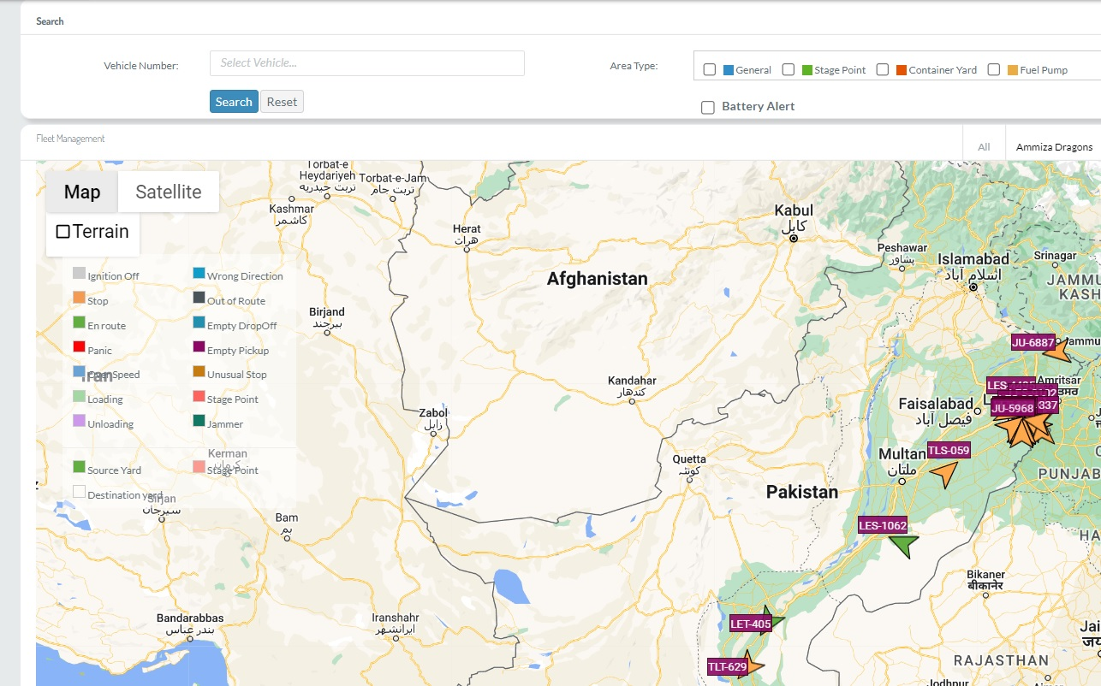

Following features are available on this screen:

# Vehicle wise search:

User can search any specific vehicle; system shows the location of searched vehicle.

# Area and Category wise search:

As shown in the above screen shot, user can setup different Area’s and Categories, and can filter the vehicles accordingly.

# Alerts

Alerts can also be generated on specific events.

Location and engine on/off status is reported periodically – configurable interval. Know the exact spot of your fleet vehicles, whether they’re travelling or are parked. Alerts are reported in real time. Save snapshots of their current status and share their location

# Trip logs

* Track your mileage, complete with log history
* Use the Business trip indicator for deductible expenses
* Get historical data per trip with Behavioral indicators and malfunction alerts.

# Live Vehicle Location and Current Status:

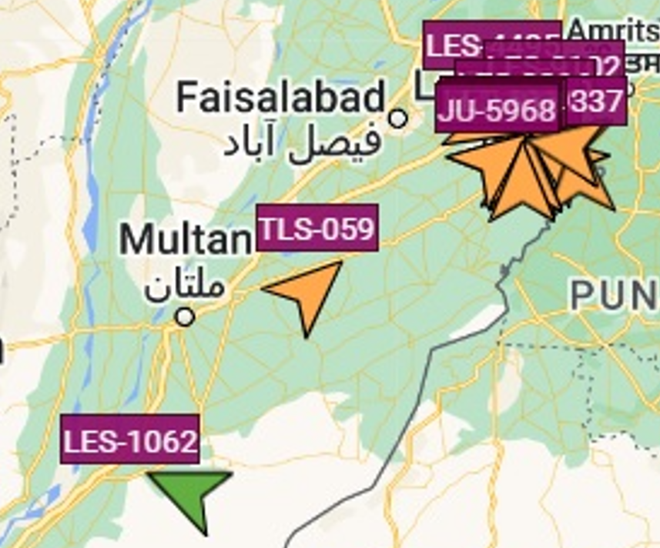

Live tracking module allows to view the vehicles with current location and status. Like in above screen shot vehicle number JU 5968 is standing idle with the other vehicles, and vehicle number LES 1062 is on the way to destination.

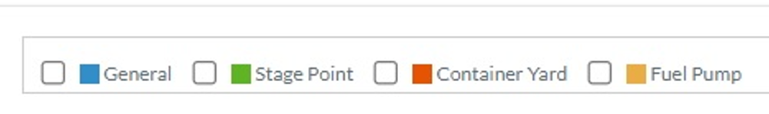

Vehicles can also have monitored according to the configured stages or events, like, vehicle which are in container yard or in specific drop off or pick up point.

# Fleet Management Operations:

# Job Management

Job based module, which allows to track all the jobs (Active / completed) on real time basis. It allows to monitor the pre-defined KPI’s as well. User can achieve the following objectives:

1. Planning Orders
2. Inbound / Outbound Monitoring
3. Dynamic and Static routing
4. Alerts
5. Third Party suppliers

# Job Executing

1. En-Route Monitoring
2. Event Management
3. Mobile App support
4. Live Tracking
5. Sensor based data capturing
6. Third party alerts and monitoring

Job Ending:

1. Integration with Payroll Module
2. Integration with FMS
3. Real time reporting.

# Maintenance management:

Keep your fleet safe and in pristine condition with maintenance tasks and maintenance reminders. Get your vehicles serviced on time and drastically reduce downtime and lost man hours, minimizing maintenance costs and maximizing your fleet’s resale value.

# Resource Management

RELISYS fleet management module empowers users to management the resources.

# Mobile App - Warehousing

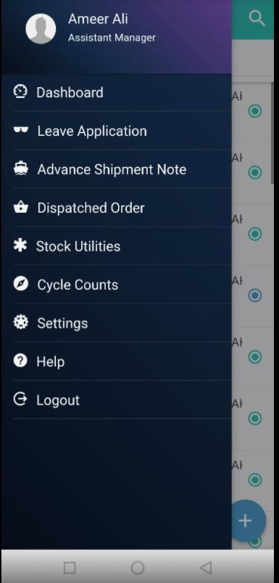Highlights of mobile is below

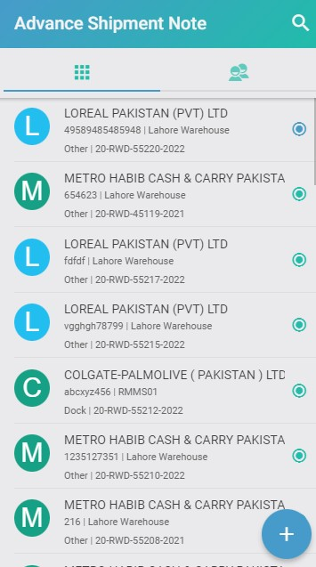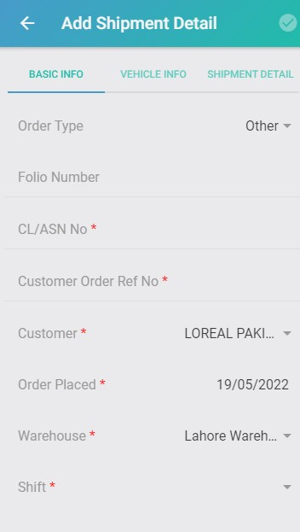

# ASN Put away

Users can put away inventory on suggested location by system. User can scan pallet and locations

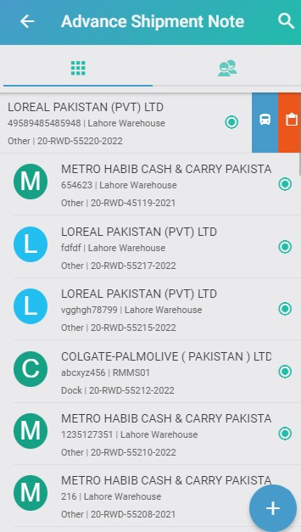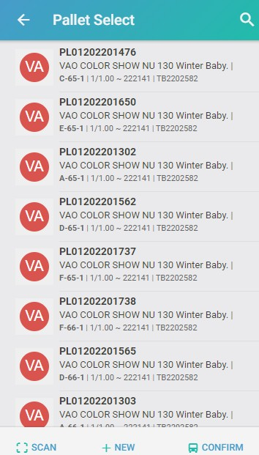

# Outbound - Dispatch Orders

Users can create the orders from mobile app, can

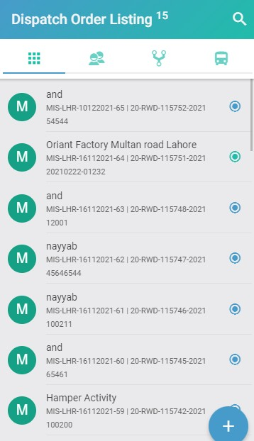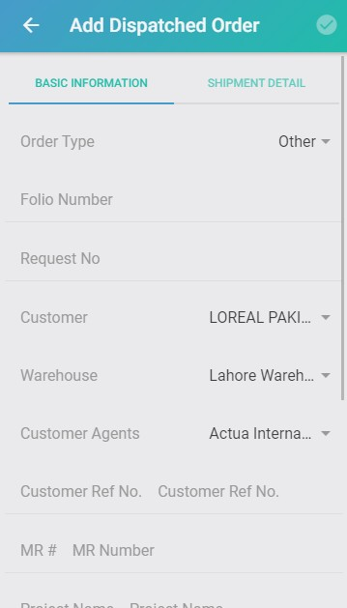

# Mobile App – Fleet Management

Mobile app version of fleet management can be shared with transporters (these must be registered with the system) and transporters can view and accept (process) new requests via mobile app:

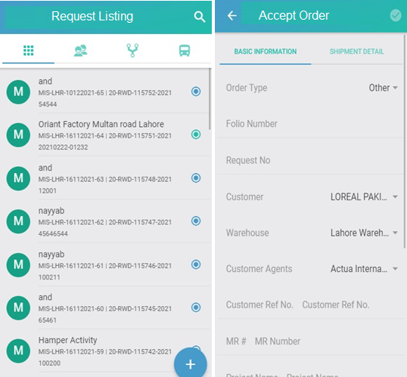

Mobile app can also show the relevant milestones associated with as specific order. And in case tracking is not available, driver can update the milestones for visibility.

# Tracking – Mobile App:

